**THE DIFFICULTIES FACED BY IX STANDARD STUDENTS IN LEARNING SENTENCE PATTERNS AT GOVERNMENT HIGHER SECONDARY SCHOOL, SAYANAVARAM**

A Field Study Submitted To

**GOVERNMENT ARTS AND SCIENCE COLLEGE,**

**ARAKKONAM-631051**

In partial fulfillment of the requirements for the degree of

**MASTER OF ARTS IN ENGLISH**

BY

**R.DHANUSH**

REG.NO: 35621P02001

Under the Guidance of

S.SURESH KUMAR, D.TEd, MA, M.Ed., M.Phil., SET



PG DEPARTMENT OF ENGLISH

GOVERNMENT ARTS & SCIENCE COLLEGE

ARAKKONAM-631051,

JUNE-2022

**FORM-A**

**TITLE OF FIELD STUDY** : THE DIFFICULTIES FACED BY IX

STANDARD STUDENT IN

LEARNING SENTENCE PATTERNS

AT GOVERNMENT HIGHER

SECONDARY SCHOOL, SAYANAVARAM

**LANGUAGE** : ENGLISH

**NAME OF THE CANDIDATE** : DHANUSH.R

**REG.NO** :  35621P02001

**AGE**  :22

**MALE/ FEMALE** : MALE

**DEPARTMENT**  : PG ENGLISH

**YEAR/SEMESTER** : I/II

**COLLEGE ADDRESS**  :GOVERNMENT ARTS AND

SCIENCE COLLEGE, Arakkonam.

**RESEARCH SUPERVISOR :** S.SURESH KUMAR, D.TEd, MA, M.Ed.,

M.Phil. SET

**CERTIFICATE**

It is certified that Mr. **DHANUSH. R, M.A.,** Government Arts and Science College, Arakkonam, truly conducted her Field entitled, “**FIELD STUDY ON**  **THE DIFFICULTIES FACED BY IX STANDARD STUDENTS IN LEARNING SENTENCE PATTERNS AT GOVERNMENT HIGHER SECONDARY SCHOOL, SAYANAVARAM.”** for 10/12/2021 in Government Higher Secondary School, Sayanavaram. We acknowledge and appreciate her Work.



**S.SURESH KUMAR, D.TEd, MA, Dr. P. Samuel, M.A., B.Ed.,**

**M.Ed., M.Phil., SET M.Phil., Ph.D.,**

ResearchSupervisor, HOD, PG Department of English

Government Arts & Science College, Government Arts & Science

Arakkonam-631051 College Arakkonam-631051

**R.DHANUSH**

**Government Arts and Science College**

**Arakkonam-631051**

**DECLARATION**

**DHANUSH.R,** herebydeclare that the field Study entitled **THE DIFFICULTIES FACED BY IX STANDARD STUDENTS IN LEARNING SENTENCE PATTERNS AT GOVERNMENT HIGHER SECONDARY SCHOOL, SAYANAVARAM** is the result of my original and independent research work, carried out under the guidance of **S. SURESH KUMAR D.TEd M.A., M.Ed., M.Phil., SET.,** Government Arts and Science College, Arakkonam and that it has not been submitted for the award of any Degree, Diploma, or Fellowship or any other similar titles of any university or institution previously.

**Place: Arakkonam DHANUSH.R**

**Date:**

**ACKNOWLEDGEMENT**

First and foremost I am indebted to the Govt, Arts and Science College, Arakkonam for permitting me to do this field study in the Department of English.

I am immensely thankful to Dr. P. Bama**, Government Arts and Science College, Arakkonam, for** extending her moral support.

I express my sincere thanks to **Dr.P.SAMUEL, Assistant Professor and Head, PG Department of English, Government Arts and Science College, Arakkonam,** for his moral support that enable me to complete this work on time.

I am gratefully acknowledged to **S.SURESH KUMAR D.TEd M.A., M.Ed., and M.Phil. SET.**  For his profile and efficient guidance during every move of the writing of my field study. His patience and care, his enormous suggestions for improvement, his correction of errors and his stylistic comments have been invaluable. I gratefully remember once again my mentor.

I am highly indebted to all staff of the Department of English, whose valuable suggestion were useful in complete this work.

I am thankful to my beloved parents and my friends for their devoted dedicated series and suggestions during the period of my field study.

| **S.NO** | **CONTENT** | **PAGE**  **NO** |
| --- | --- | --- |
| **1.**  **2.**  **3.**  **4.**  **5.**  **6.**  **7.**  **8.**  **9.**  **10.** | Introduction  Place of study  Field study tools  Statistical collection  Need and Purpose of Study  Field Study Work Plan  Photographs  Statistical Analysis  Study Results  Implementing The-Solution | **3**  **3**  **4**  **4**  **4**  **5**  **16**  **17**  **17**  **20** |

**THE DIFFICULTIES FACED BY IX STANDARD STUDENTS IN LEARNING SENTENCE PATTERNS AT GOVERNMENT HIGHER SECONDARY SCHOOL, SAYANAVARAM**

**INTRODUCTION**

A Sentence pattern is an arrangement of words. This arrangement needs to be in a grammatically correct structure. It means the placement of verb and nouns should be correct to form a meaningful sentence. Apart from that, there are punctuations which play an important role in making a sentence readable and understandable. Without the correct placement of words, students can't not express the thoughts properly while speaking. Same way, without proper use of punctuations, students can't express the thoughts effectively in writing note that the structure and pattern differ from different language.

In grammar, a sentence is the basic grammatical unit. It contains a group of words and expresses a complete thought. A Sentence consists of a subject and a predicate. For example, in the sentence “Tagore is the subject of the sentence and writes good poem is the predicate. English learners and writers are required to study different aspect of the language. i.e. noun verb, adjectives etc. But that is not enough. They also have to consider the sentence as a whole this means students have to learn basic sentence patterns. When students are writing an assignment, the pattern and structure of a sentence will be the most important things for students to consider. In order to make IX standard students sentences meaningful and effective, students will have to learn how to make correct sentence using different patterns. If you are a student or a beginner in the writing field, in learning and mastering the patterns will help you perform well in your English language tests. It will also help students improve your writing skills in English. There are several patterns of sentences, but we will discuss some of the common and basic patterns. In English, learner want to write a sentence, you have to use to important parts which are subject and verbs. When putting together, students will express correct thoughts in an understandable sentence.

A sentence has two basic elements: the subject and the predicate. The subject is always a noun, a pronoun, or a group of words acting as a noun. It is what the entire sentence is about. Meanwhile, the predicate contains a verb that describes the subject. Take note, verbs do not always have to be action verbs. Lastly, subjects and predicates can be either simple or compound. In English grammar, there are 5 basic sentence types students need to be familiar with. But before we proceed to the main topic, let us first review the importance of a sentence and the elements we can find within it. Previously, we considered English sentences as the most necessary tool for communication. Why? Because a person’s ability to write and speak effectively depends on how good they are at forming sentences. Meanwhile, it would be more difficult to understand the basic sentence patterns in English. If there are not familiar yet with the basic sentence structure in English. So, students better learn this first for students to comprehend this topic more easily. To begin with, here’s a quick review of sentences. The Basic Elements of a Sentence. Each patterns is described with an example below. The subject is represented by S and verb by V in the examples.

Knowing basic grammar is important in order to be able to analyze and improve your language performance. Understanding the use of noun, verb, adverb, adjective, phrase or clause help your to write English better. For example, to write a letter, learns need to know the rule of sentence structure, the rule of words order like. Furthermore, writing requires a lot of mental effort. Most English learners do their writing tend to make mistake and misuse of grammar rules, which are very easy to recognize.

Knowing basic grammar is an important tool for reader to understand what they are reading. It is considered to be a handle of literature. News stories and poems have a lot of long sentence. Using grammar to define which one is subject, verb, object, phrase or adverbial clause. By analyzing the grammar of sentence and paragraphs, the readers can understand what they read better. The findings showed that the problems of writings or readings sentence are helpful in this survey.

**IMPORTANCE OF SENTENCE PATTERN**

1. Sentence structure is important because it provide us with the framework for the clear written expression of our ideas.
2. The aim in writing is always to write in complete sentences which are correctly punctuated.
3. Sentences always begin with a capital letter and end in either a full stop, examination or question mark.
4. When student are writing an assignment, the pattern and structure of a sentence will be the most important things for students to consider. In order to make the sentences meaningful and effective.
5. Student will have to learn how to make correct sentence using different pattern.

**PLACE OF STUDY**

1. Field study took place at Government Higher Secondary School.
2. It is located at Sayanavaram which is Nearby Senthamangalam road.
3. The Sample taken for field study is IX standard students.
4. I have taken both English & Tamil medium students.
5. The time period taken for the study is from December 10.

**FIELD STUDY TOOLS**

1. Senior's Project work. (For reference)
2. Statistical Data for Study.
3. Information to YouTube videos sentence pattern through Internet.
4. IX Standard English text book.

**STATISTICAL COLLECTION**

I have 20 students for my field study.

Questionnaire from students.

**NEED AND PURPOSE OF STUDY**

1. The purpose of study is to know the follow the rules and to know about at least basic knowledge in sentence pattern.
2. With the help of sentence pattern students will improve their writing in language.
3. Besides students will write essays, reports, letters, in school level correctly.
4. It is important to learn the most common sentence patterns in English, as most of the sentence students will hear, write, and speak will follow these basic patterns.

**FIELD STUDY WORK PLAN**

Selection of site for study



Selecting the Tools for study



Preparation of Quiz List for Statistics Collection



Statistical Collection



Statistical Analysis

Knowing the Details of the problem form the Results



Consulting and Deciding On a Solution



Solution Implementation

**THE DIFFICULTIES FACED BY IX STANDARD STUDENTS IN LEARNING SENTENCE PATTERNS AT GOVERNMENT HIGHER SECONDARY SCHOOL, SAYANAVARAM**

**STUDENT’S DETAILS WITH QUESTIONS**

Student Name:

School Name:

Standard :

Section :

Medium :

**YES (OR) NO TYPE QUESTIONS**

1. Did you know about the grammar?

Yes (or) No

1. Do you understand the sentence patterns?

Yes (or) No

1. Is the English grammar interest to you?

Yes (or) No

1. Is the sentence pattern easy to you?

Yes (or) No

1. Are you studying in English medium?

Yes (or) No

**CHOOSING THE CORRECT SENTENCE PATTERNS**

1. Boys are playing in the ground.
   1. SVO
   2. SVC
   3. SVA
   4. SVOO
2. Kalpana cooks very well.
   1. SVA
   2. SVO
   3. SVC
   4. SVO
3. He is sleeping.
   1. SV
   2. SVO
   3. SVC
   4. SVA
4. India become independent in 1947.
   1. SVOA
   2. SVA
   3. SVOO
   4. SVAC
5. The doctor gave up a shot.
   1. SVOO
   2. SVOC
   3. SVA
   4. SVOA
6. All women love jewels and silk sarees.
   1. SVC
   2. SVO
   3. SVA
   4. SVOA
7. My sister speaks English very well.
   1. SOA
   2. SVO
   3. SV
   4. SVOA
8. The doctor advised him to complete rest.
   1. SVOC
   2. SVCC
   3. SVOA
   4. SVOO
9. I have finished writing books.
   1. SVOO
   2. SOC
   3. SVA
   4. SVO
10. They felt the floor vibrate.
    1. SVOC
    2. SVOO
    3. SVAC
    4. SVO
11. Dhoni played well.
    1. SVO
    2. SVC
    3. SVA
    4. SV
12. She became a teacher.
    1. SVCA
    2. SVO
    3. SVA
    4. SVC
13. We play cricket.
    1. SVO
    2. SVA
    3. SVC
    4. SV
14. I wish you happy New Year.
    1. SV
    2. SVIODO
    3. SVA
    4. SVOA
15. The sun shines.
    1. SVA
    2. SV
    3. SA
    4. SVO

**STATISTICAL ANALYSIS**

Interview with taken school students by giving questionnaire. The study was also conducted through the observation of students about the impact on ‘Correct sentence pattern'.

**STUDY RESULT**

Total number of students: 20

Number of boys: 13

Number of girls: 07

**PIE CHART**

Number of Low mark Students: 7 to 9 = 50%

Number of Average mark Student: 9 to 11 = 30%

Number of High mark students: 11 to 15 = 20%

**RESPONSES RECIVED FROM STUDENTS**

1. The students are questioned that “boys are playing in the ground” in this sentence choose the correct sentence pattern among 20 students, 7 students opted A, 3 students opted B, 10 students opted C.
2. The students are asked “Kalpana cooks very well” in this sentence choose the correct sentence pattern, among 20 students, 5students opted A, 6 students opted B, 8 students opted C, 1 student opted D.
3. The students are asked “He is sleeping” in this sentence choose the correct sentence pattern, out of 20 students 10 students opted A and other 5 opted B, 2 students opted C, 3 students opted D.
4. The students are asked “India become independent in 1947”in this sentence choose the correct sentence pattern, out of 20 students 3 students opted A, 9 students opted B, 3 students opted C, 5 students opted D.
5. The students are asked “The Doctor gave up a shot” in this sentence choose the correct sentence pattern, among 20 students 7 students opted A, 1 student opted B, 8 students opted C and 4 students opted D.
6. The students are asked “All women love jewels and silk sarees” in this sentence choose the correct sentence pattern, among 20 students, 2 students opted A, 6 students opted B, 7 students opted C, 5 students opted D.
7. The students are asked “My sister speaks English very well” in this sentence choose the correct sentence pattern, among 20 students 2 students opted A, 9 students opted B, 1 student opted C,8 student opted D.
8. The students are asked “The doctor advised him to complete rest” in this sentence choose the correct sentence pattern, among 20 students 2 students opted A, 3 students opted B, 3 students opted C, 12 students opted D.
9. The students are asked “I have finishing writing books” in this sentence choose the correct sentence pattern, among 20 students 2 students opted A, 9students opted C, 9 students opted D.
10. The students are asked “They felt the floor vibrate” among 20 students 9 students opted A, 1 student opted B, 4 students opted C, 6 students opted D.
11. The students are asked “Dhoni played well” among 20 students 1 student opted A, 2 students opted B, 4 students opted C, 13 students opted D.
12. The students are asked “She become a teacher” among 20 students 2students opted A, 2 students opted B, 3 students opted C, 13 students opted D.
13. The students are asked “We play cricket” among 20 students 7 students opted A, 7 students opted B, 2 students opted C, 4 students opted D.
14. The students are asked “I wish you happy new year” among 20 students 1 student opted A, 14 students opted B, 5 students opted C,
15. The students are asked “The sun shines” among 20 students 2 students opted A, 12 students opted B, 5 students opted C, 1 students opted D.

**Photograph**



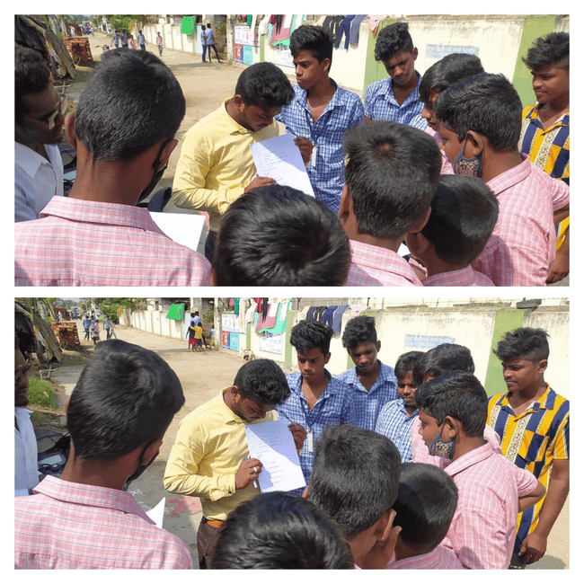

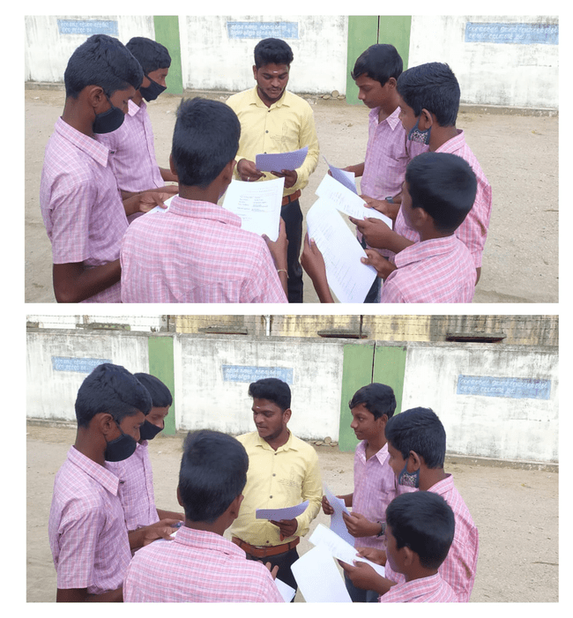

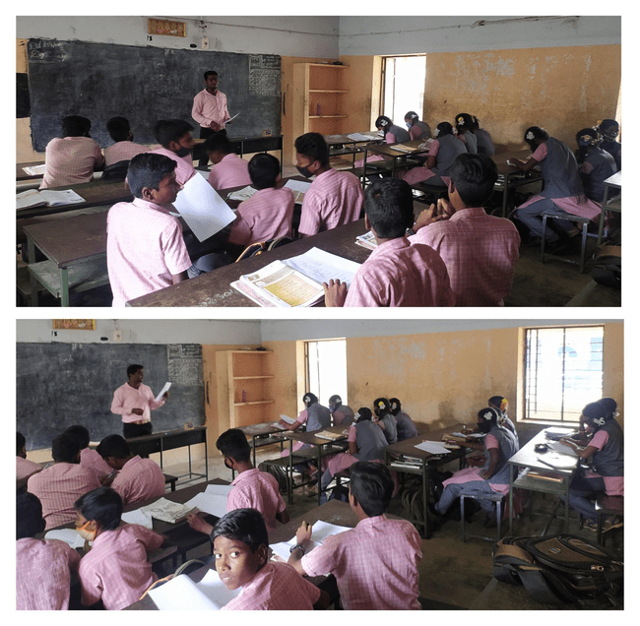

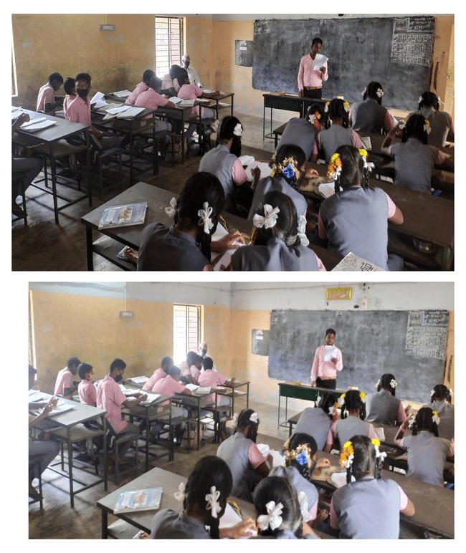



**IMPLEMENTING THE SOLUTION**

The teachers should mould their students to write sentence correctly. The teachers must train their students by teaching rules with examples. The teacher can ask questions to students from the text book which was designed for them. The teacher should ask questions before starting the lessons.

**CONCLUSION**

In this field study the work is concluded by detailed examination about learning sentence patterns among IX standard students. In English, there is always a need to write a sentence, we must use important parts such as subject, verb, and so on. If students are beginners in the writing field, learning and mastering the patterns will help them to perform well in English language tests. While writing an assignment, the pattern and structure of a sentence will be most important things to be consider.

This survey was conducted in government higher secondary school sayanapuram. Data/details are collected IX standard students. After a detailed study we came to know that have poor grammatical knowledge and the students the reason. Behind that is lack of teaching in their primary classes from first to eight standard. Beside students are also from rural background and their parents are also illiterate. Facing such kind of unusual environment/background students one struggling to learn to learn sentence pattern.

In the end of the study it is concluded to give solution for the problem faced by IX standard students, need to concentrate to improve students reading skills in English. Students need to practice the sentence pattern with the help of teachers. Pronunciation training and practice to be given for IX standard students.

Given problem in the writing practice write rules of sentence pattern should be spelling errors. The teachers must train their students with audio and visual aids for teaching sentence pattern to IX standard students. The focused on the almost importance. Should be interaction between students and teachers. The most interactions in the class will improve the IX standard student in learner sentence pattern.